TYPE: Science Inquiry

TASK 6: Enzymes Investigation (50 marks)
Students are to plan, execute and write up an investigation on enzymes. This task will be completed in three sessions - two in groups and the final report by themselves

Time for the tasks (1 hour)
- 5 minutes reading time
- 55 minutes working time

What you need to do:

- You may use information/ data from your planning and experimental stages of this Investigation.

- Follow instructions on the attached Assessment Instructions page.

- It is your responsibility to organise your time effectively.

- There is to be no discussion between you or any of your class mates.

Requirements for assessment | Due dates:
- Complete all questions | ___________________

DO NOT TURN THIS PAGE OVER UNTIL YOU ARE TOLD TO

STAGE | MARKS | YOUR MARK
PLANNING | 5
EXPERIMENT | 5
REPORT | 40
TOTAL | 50

STUDENT NAME: ________________________________________________________________

TEACHER: Ms Andrews Mr Schembri YEAR: 11

ENZYME INVESTIGATION PART 3 – The Report

1. Individually, you are to write a report about your Enzyme Investigation. (35marks)

It should follow the format/subheadings of the picture from your textbook below.

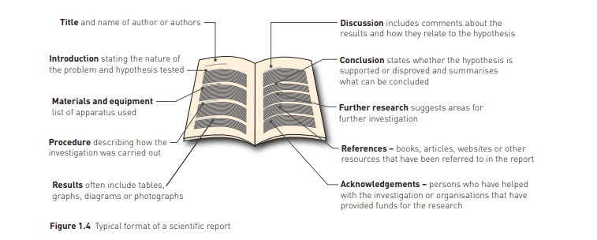

2. Answer the following questions about your Investigation: (5 marks)

a. What was the independent variable? __________________________________________

b. What was the dependent variable? ____________________________________________

c. Identify two controlled variables ______________________________________________

_______________________________________________________________________________

d. Write an appropriate hypothesis for your investigation.

______________________________________________________________________________________________________________________________________________________________________________________________________________________________________________________

Notes: Attach these pages to your report.
You may use data and information from your planning and experimental stages without rewriting it if it is neat, organized and legible.

